Kevin Sun, Danny Oh, and Chris Zhu

ICS4U

Ms. Coderre

March 2nd, 2015

**Project Plan**

# Table of Contents

**1.0 Introduction** **2**

1.1 Project Introduction 2

1.2 Goals 2

1.3 Challenges 2

1.3.1 Development 2

1.3.2 Application 2

**2.0 Requirements 3**

2.1 Features 3

2.2 Technology 3

2.3 Client Requirements 3

**3.0 Deliverable List 4**

**4.0 Tasks 4-8**

4.1 Work Breakdown 4

4.2 Major Milestones 5

4.3 Schedule & Progress Tracking 6

4.4 PERT Chart - Critical Path 7

4.5 Gantt Chart 8

**5.0 Resources 8-9**

5.1 Software Development Life Cycle 8

5.2 Team Structure 9

5.3 Software 9

5.4 Hardware 9

**6.0 Project Management 10**

**7.0 Risk Analysis 11**

**8.0 Team Policies 12**

8.1 Communication Policy 12

8.2 Quality Assurance Policy 12

**1.0 Introduction**

1.1 Project Introduction:

Our program is a web based java applet game created for grade 10 high school students that are currently taking SNC2D. It is a hidden puzzle game where the player is presented with different screens of hidden objects and corresponding hints. Players must use both their eyesight and their minds in order to find the correct objects. Along with the act of finding these objects, there will be several different methods for reviewing past course material that will allow students to review and practice for their summatives.

1.2 Goals:

The goal of the game is to find all the science-objects that are related to the hints given. Specifically, as each screen relates to one specific unit, each object and hint will also correspond to one topic within those units. Upon finding an object by deciphering the hints, players will be able to view the ‘object’ again in a ‘Collections’ tab where they will be presented with important information relating to that topic.

1.3 Challenges:

1.3.1 Development

One challenge will be acquiring feedback from our users, as we will likely have little-to-no workshops with the users until the final product is released. Our prototype testing and revisions will be based mostly on peer and our client’s feedback. However, meeting with our client may also be difficult, depending on their schedule as a teacher (reports, marking class work, meetings, etc.).

1.3.2 Application

One challenge that will be faced when developing the project is the connection of the visual components with the course material. While some course materials may be easier to visualize and draw than others, there are also several topics, such as chemical bonding, which may be difficult to implement into a ‘hidden-object’ styled game.

Another challenge that will be faced will be ensuring the program will sufficiently cover the client’s course curriculum. The singular screens per unit with singular objects used for students to review course material may lose out on important explanations and concepts required for the curriculum.

**2.0 Requirements**

2.1 Features

* **Inventory** - Objects that were previously found will be stored in an “inventory” and can be accessed to review what the objects are, and further explanations for each objects.
* *Stores objects currently found within the unit (‘level’) with a short summary of information on that topic*
* **Hint Coin System** - For every 3 objects found, the player will be granted 1 hint coin, which can be used to receive a hint in case the clue given isn’t specific for them.
* *A game-wide ‘currency’ spent to reveal the answer to the hints within the game*
* *Gained by finding 3 correct objects on any screen*
* **Collections Tab** - Selecting collections button in the menu will bring students to an index of the objects they have found, and for every object found, the review for the course will be able to be viewed.   
  If the student finds all the objects from a unit, additional bonuses such as additional hint coins, fun facts, etc will be given.
* *Tab on the main menu screen which brings students to an index of the objects they’ve found for each unit*
* *Summaries of topics within each unit for student to review based on which objects they’ve found*
* *Upon completing any full unit, additional bonus is unlocked (additional hint coins, fun facts, etc.)*

2.2 Technology

* Eclipse SDK will be used to code the program in the Java language
* Computers will be used to access the final product via an embedded jApplet on a website

2.3 Client Requirements

* The client requested for the software to be done before the summative projects and final exams, so that the grade students in SNC2D and SNC2P can use the program to review the curriculum before the summative project and final exam periods.
* The client also asked for some must-have topics such as:

1. Types of reaction and balancing equations (Chemistry)
2. Ray diagrams for Mirrors vs Virtual Images (Optics)
3. Human Body Systems and its Connections (Biology)

**3.0 Deliverable List**

*Game Resources:*

* Concept Art
  + Image References
  + Level Designs
* Sound effects & music
* 2D Graphics
  + Background images for each screen
  + Object images
  + User Interface Design
* Source Code

*Documentation:*

* Concept Document
* Project Plan
* Design Document

**4.0 Tasks**

4.1 Work Breakdown

*Product Management*

* Scheduling
* Client satisfaction and Quality assurance
* Documentation

*UI Design*

* Research color and Usability Conventions
* UI Integration
* UI Concept art

*Program Development*

* Program logical structure
  + Player progression tracking
  + Object interactivity
  + Menu navigation
* Features Implementation
* Alpha and Beta Prototypes and testing
* Website Integration
  + Research embedding JApplets into HTML websites
  + Research cookie-based storage
* Debugging & Efficiency checking
* Final Release and Maintenance

*Educational Information Integration*

* Program components covers client’s course expectations correctly
  + Objects, hints, review summaries all follow unit expectations

*Artwork Creation*

* Concept Art
* Backgrounds and corresponding ‘hidden’ objects
  + Must follow client’s course information

4.2 Major Milestones

*February:*

* Client specifications and initial meeting
* Concept Document and Project Plan

*March:*

* Design Proofs (Paper Prototype)
  + Program structure and UI Designed
* Concept art

*April:*

* Alpha prototype completed and tested

*May:*

* Visual assets created and implemented
  + Background and object artwork
* Beta prototype completed and tested

*June:*

* Final product released and implemented for client

4.3 Schedule & Progress Tracking

|  |  |  |  |
| --- | --- | --- | --- |
| **Task** | **Due Date** | **Notes** | **Progress** |
| Project Specifications | February 26th | 1st Meeting with client conducted | Complete |
| Research | February 26th | SNC2D curriculum | Complete |
| User Interface Design | March 6th | Need color scheming | Complete |
| Program Structure Design | March 6th |  | Complete |
| Storyboarding & Paper Prototype | March 6th | Client had positive feedback | Complete |
| Topic Specific Objects & Hints | March 16th |  | Complete |
| Unit Summaries/Explanations | March 16th |  | Complete |
| Background & Object Layout | March 16th |  | Complete |
| Program Development | April 17th |  | Complete |
| Concept Art Creation | March 6th |  | Complete |
| Testing & Revision | April 27th |  | Complete |
| Alpha Prototype Release & Tests | May 4th |  | Complete |
| Visual Asset  Creation/Integration | May 4th |  | Complete |
| Website Integration | ~~May 15th~~ | Website integration abandoned | Incomplete |
| Beta Prototype Release & Tests | May 15th |  | Complete |
| Final Prototype Construction (Debugging) | May 16th - ~~June 12th~~ |  | Complete |
| Product Release ~~& User Workshops~~ | June 13th - June 16th | Product never released publicly | Incomplete |

4.4 PERT Chart - Critical Path

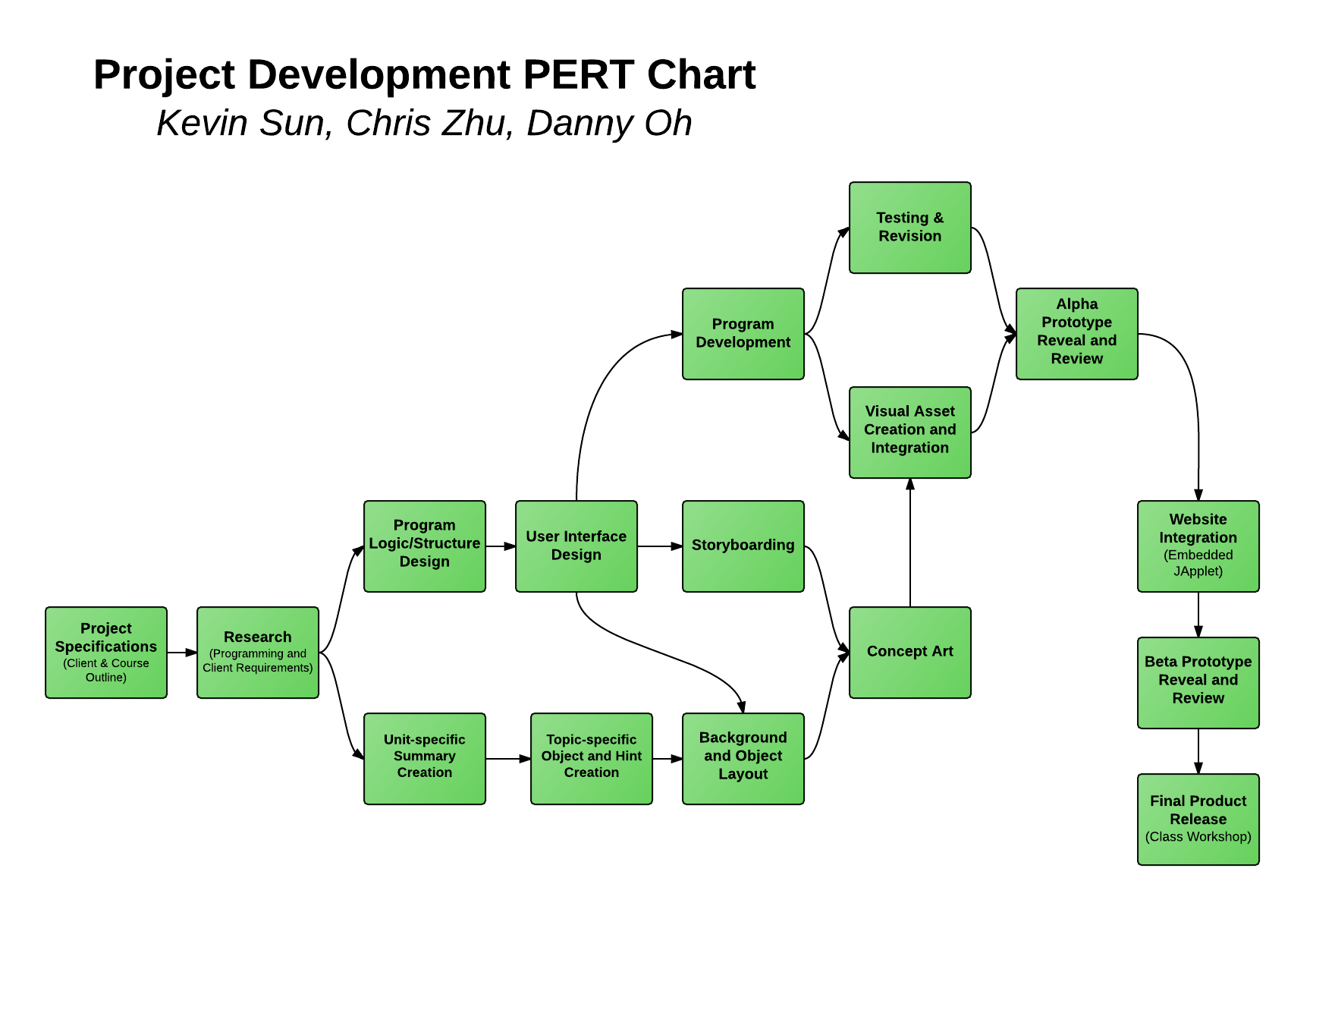

Critical Path:

As this program is a ‘hidden-object’ interactive game, the visual components are very important to the program as a whole. However, the focus of our efforts will be spent in designing and developing the program’s structure and functionality, therefore the critical path will be following the Program Development tree.

*(Specifications, Research, Structural Design, UI Design, Program Development, Testing & Revision + Visual Asset Creation & Integration, Alpha/Beta Prototyping, Final Product Release).*

4.5 Gantt Chart

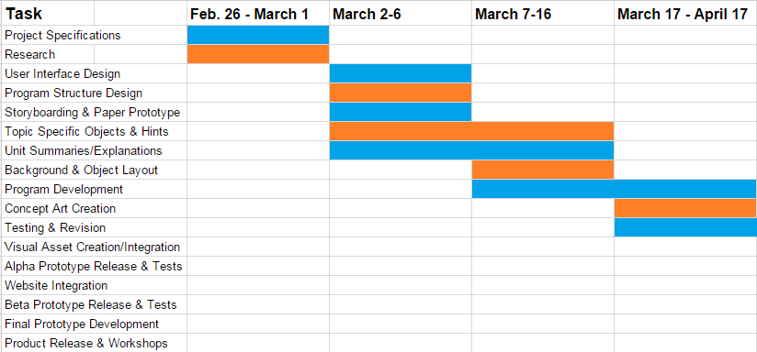

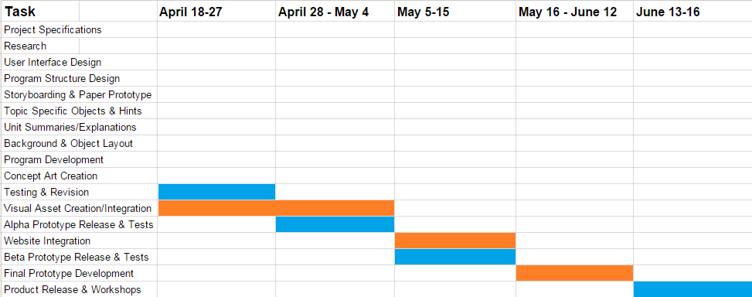

**5.0 Resources:**

5.1 Software Development Life Cycle Model

We will be using the agile model in order to allow for early functioning prototypes to gather initial feedback while still building off of one main structure and adding improvements.

5.2 - Team Structure:

Chris Zhu - Project Manager & Co-Developer

* Client meetings
* Team scheduling
* Final release Workshop
* Oversee and assist program implementation

Kevin Sun - Lead Developer

* Program logic/structural design
* UI Integration
* Web Integration

Danny Oh - Visual Designer & Researcher

* Visual Designer
  + - Visual Asset creation
    - Visual Integration of client’s course expectations
    - UI Design
* Researcher
  + - Course curriculum research
    - Create descriptions and hints for each object

5.3 Software:

* Internet Browser
* Eclipse SDK
  + CookieAccessor Class
  + Cookie Manager Class

5.4 Hardware

* Desktop Computer & Accessories (Mouse, Keyboard, Monitor)

**6.0 Project Management:**

The team structure falls into three generalized roles: Project Manager, Program Designer, and Visual Designer. As listed in 5.2, each of us are also responsible for assisting in the other roles as well, but our main priorities are in these three roles.

Chris Zhu is the Project Manager and his responsibilities are as follows:

* Client meetings
* Team scheduling
* Final release Workshop
* Oversee and assist program implementation

Kevin Sun is the Program Designer and his responsibilities are as follows:

* Program logic/structural design
* UI Integration
* Web Integration

Danny Oh is the Visual Designer and his responsibilities are as follows:

* Visual Designer
  + - Visual Asset creation
    - Visual Integration of client’s course expectations
    - UI Design
* Researcher
  + - Course curriculum research
    - Create descriptions and hints for each object

Furthermore, to ensure the team is on track and synergized, we will be following and filling in the schedule specified in 4.3.

**7.0 Risk Analysis:**

*Risk 1: Group member falls behind schedule*

* Avoidance: Group members follow the schedule as best they can,

use class work time effectively, attempt their best at the task and ask other group members for help if they run into problems

* Solution: Group members work extra hard to get back to the schedule, or

reduce the size of the project or their task

------------------------------------------------------------------------------------------

*Risk 2: Inability to code or create a component of the program*

* Avoidance: Be proficient at the code language*
* Solution: Ask peers for help or go online to find helpful information to complete the task

------------------------------------------------------------------------------------------

*Risk 3: Unable to create or find an acceptable non-copyrighted image*

* Avoidance: Try to find the images in advance so that another alternative can be planned in advance.
* Solution: Ask peers for help in finding or creating an image for the project.

------------------------------------------------------------------------------------------

*Risk 4: Project does not satisfy client specifications (not a useful tool for client)*

* Avoidance: Maintain weekly reports and meetings with client to ensure project is following client’s goals
* Solution: Meet with client to determine specifications and adjust the program to meet them

**8.0 Team Policies:**

8.1 Communication Policy:

Each team member must contact the team if they wish to make changes or adjust another member’s work. Furthermore, team meetings will be held weekly to provide updates on progress and discussions to ensure integratability of each other’s work. Communication will be done largely via online social media groups and email.

8.2 Quality Assurance Policy:

The program being developed will be used for review purposes on the client’s website; as such the quality of work must meet the client’s requirements (accurate, professional). Before finalizing any work, each team member must review with the team and discuss whether the work meets the clients specifications. Should the work not meet the standards set out for the project, the work must be revised.